**Frontend Development with React.js**

**Project Documentation format**

1. **Introduction**
   * **Project Title**: [STORE MANAGER]
   * **Team Members**: MONISH.P(LEADER)
   * **KISHAN KUMAR**.B
   * **KISHORE**.S
   * **KUMARVEL.NV**
2. **Project Overview**
   * **Purpose**: A Stores Manager Website helps organize and monitor stock, sales, and staff, making store management easier and more efficient.
   * **Features**:
     + Dashboard overview
     + Inventory management
     + Sales & billing
     + Employee management
     + Customer management
     + Supplier tracking
     + Sales & inventory reports
     + Profit & loss reports
     + Multi-store support
     + Role-based access
3. **Running the Application**
   * Provide commands to start the frontend server locally.
     + **Frontend**: npm start in the client directory.
     + Visual studio
4. **Component Documentation**
   * **Key Components**: Document major components, their purpose, and any props they receive.
   * **Reusable Components**: Detail any reusable components and their configurations.
5. **State Management**
   * **Global State**: Describe global state management and how state flows across the application.
   * **Local State**: Explain the handling of local states within components.
6. **User Interface**
   * Provide screenshots or GIFs showcasing different UI features, such as pages, forms, or interactions.
7. **Styling**

* **CSS Frameworks/Libraries**: Describe any CSS frameworks, libraries, or pre-processors (e.g., Sass, Styled-Components) used.
* **Theming**: Explain if theming or custom design systems are implemented.

**8.Testing**

* **Testing Strategy**: Describe the testing approach for components, including unit, integration, and end-to-end testing (e.g., using Jest, React Testing Library).
* **Code Coverage**: Explain any tools or techniques used for ensuring adequate test coverage.

**9.Screenshots or Demo**

* Provide screenshots or a link to a demo showcasing the application’s features and design.

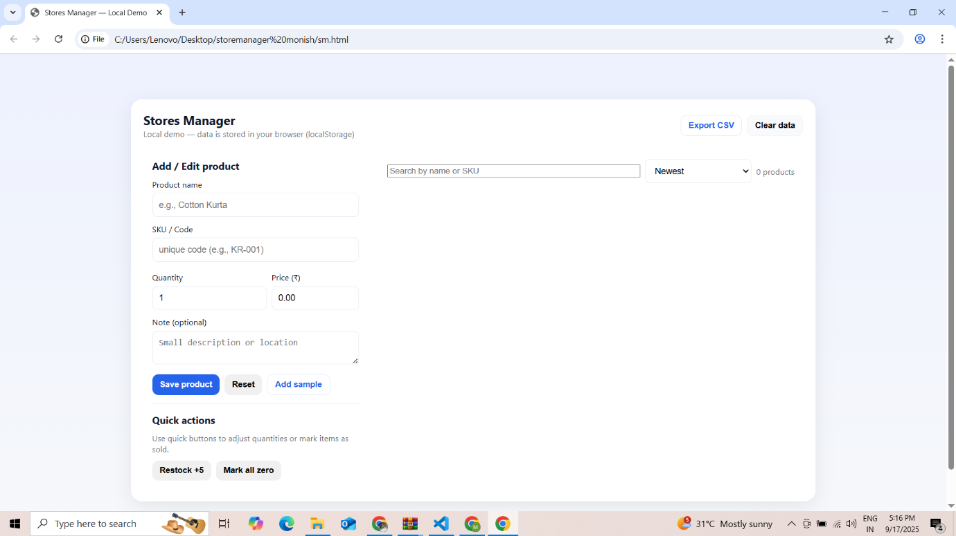

**10.Known Issues**

* Document any known bugs or issues that users or developers should be aware of.

**11.Future Enhancements**

* Outline potential future features or improvements, such as new components, animations, or enhanced styling.

Documentation link : https://drive.google.com/file/d/1JWvO3BiQL1Xiu4AzBzQf_enf7xlNRczC/view?usp=drivesdk